Charles Albert Schorey
January 5, 1876 – June 19, 1947

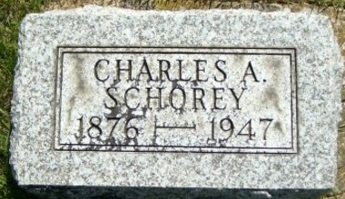
Photo by Smalltown

Charles Albert Schorey in howard schorey family tree
Spouse Mary Matilda Goldner
Father Johannes Schori
Mother Susannah F. Ditzler
Children John Howard
Birth 5 Jan 1876 Osnaburg, Stark, Ohio, USA
Death 19 Jun 1947 Bluffton, Wells, Indiana, USA
Residence 1920 Wells, Indiana, USA

