Floyd Schoeff
August 1, 1915 – December 24, 1997

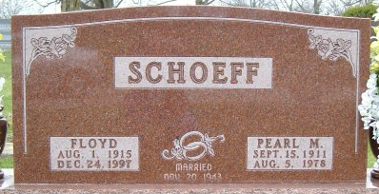
Photo by Tombstoner & Family

Floyd Schoeff, 82, of Bluffton died Wednesday at Christian Care Center.
The Wells County native was the widower of Eugenia, who died in 1942, and Pearl, who died in 1978. Surviving are his wife, Jane Bulger; sons, Jack of Bluffton, Don of Douglasville, Ga., and Boyd of Ossian; a stepson, Douglas Patterson of Bluffton; a stepdaughter, Vicki Studebaker of Bluffton; a sister, Velma Rock of Portland; nine grandchildren; seven step grandchildren; 19 great-grandchildren; 15 step great-grandchildren; and one great-great grandchild.
Services are 10:30 a.m. Saturday at Goodwin Memorial Chapel, Bluffton, with burial in Elm Grove Cemetery. Calling is noon to 9 p.m. today at the funeral home.

Fort Wayne News-Sentinel, Allen County, Indiana
Friday, December 26, 1997
**

Indiana, U.S., Death Certificates, 1899-2017

Name Floyd Schoeff
Gender Male
Race White
Age 82
Marital Status Married
Birth Date 1 Aug 1915
Birth Place Wells Co., Indiana
Death Date 24 Dec 1997
Death Place Bluffton, Wells, Indiana, USA
Death Registration Date 1997
Father Charlie Schoeff
Mother Bessie Newhard
Spouse Jane Bulger
Informant Jack Schoeff; son; Bluffton, Indiana
Burial December 27, 1997; Elm Grove Cemetery; Bluffton, Indiana

