Layke Dwight Scherry
January 7, 1916 – December 17, 1977

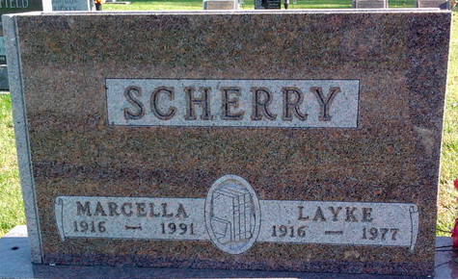
Photo by Thomas Liby

Layke Dwight Scherry
in the Indiana, U.S., Death Certificates, 1899-2017

Name Layke Dwight Scherry
Gender Male
Race Caucasian (White)
Age 61
Marital Status Married
Birth Date 7 Jan 1916
Birth Place Indiana Adams Co.
Death Date 17 Dec 1977
Death Place Columbia City, Whitley, Indiana, USA
Death Registration Date 1977
Father William Scherry
Mother Fern Mechling
Spouse Marcella Williams
Informant: Marcella Scherry; wife; Columbia City, Indiana
Burial: December 21, 1977; Elm Grove Cemetery; Bluffton, Indiana

