Howard E. Sawyer
May 11, 1909 – July 1, 1997

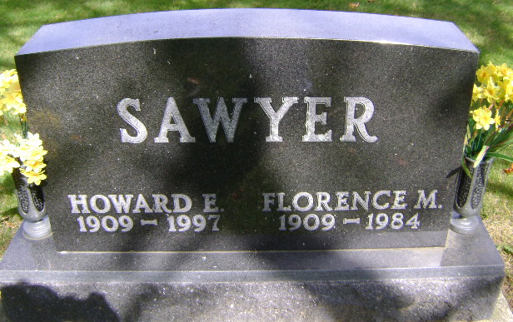
Photo by Bruce Sonner

Howard E. Sawyer
in the Indiana, U.S., Death Certificates, 1899-2017
Name Howard E. Sawyer
Gender Male
Race White
Age 88
Marital Status Married
Birth Date 11 May 1909
Birth Place Wells Co, Indiana
Death Date 1 Jul 1997
Death Place Bluffton, Wells, Indiana, USA
Death Registration Date 1997
Father Emanuel Sawyer
Mother Emma Narr
Spouse Hildra Houser
Informant Hildra Sawyer; wife; Bluffton, Indiana
Burial July 3, 1997; Elm Grove Cemetery; Bluffton, Indiana

