Ida May (Stephenson) Sandberg
September 26, 1894 – January 9, 1986

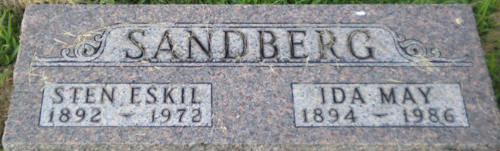
Photo by PLGS

Ida Sandberg
in the U.S., Social Security Death Index, 1935-2014
Name Ida Sandberg
Social Security Number xxx
Birth Date 26 Sep 1894
Issue year Before 1951
Issue State Indiana
Last Residence 74006, Bartlesville, Washington, Oklahoma, USA
Death Date Jan 1986
**
Ida Mae Stephenson from tree Gwinn - Indiana
Record information.
Birth 26 Sep 1894 Adams, Indiana, USA
Marriage 24 Dec 1930 Bluffton, Wells, Indiana, USA
Residence 1951 Indiana, USA
Death 9 Jan 1986 Bartlesville, Washington, Oklahoma, USA
Record information.
Father Jesse Edward Stephenson (1868-1938)
Mother Rachel Malinda Cline (1873-1951)
Spouse Steve Lonberg (Born 1893) [I believe this is Sten Sandberg]
Spouse George Washington Harris (1889-1929)
Spouse Marshall Emmett Ross (1892-1962)
Spouse Leon Mason Grimes (1893-1967

