Beverly J. (Lobsiger) Rich
November 4, 1933 – June 19, 2025

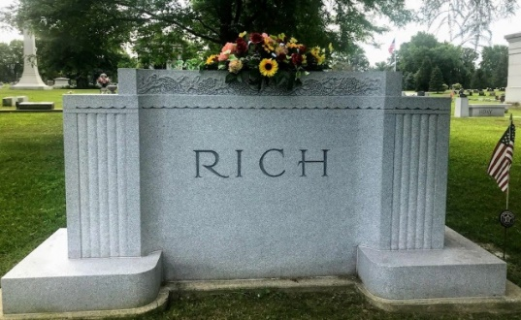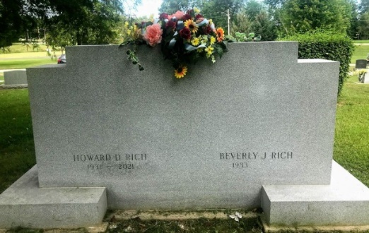
Photo by SMMR

Beverly J. Rich, 91 formerly of Bluffton passed away on Thursday afternoon, June 19, 2025, at Hoosier Village in Indianapolis, IN.
Beverly was born on November 4, 1933 in Convoy, Ohio to Paul and Margaret (Daniels) Lobsiger.
She graduated from Adams Central High School in 1951 and furthered her education at Fort Wayne Lutheran Hospital Nurses Training school where she obtained her RN. Beverly spent her nursing career working at Caylor-Nickel Clinic. She was a longtime member of the First United Methodist Church in Bluffton. Beverly enjoyed reading, music and the Arts. She was musically inclined, playing the piano and the harp.
On June 26, 1955, Beverly and Howard Rich were married in Monroe, IN. The couple shared many years supporting Bluffton and Wells County. They enjoyed traveling the world and exploring the cultures. Their life together was a “true adventure.” He preceded her in death on June 6, 2021.
Survivors include her sons, D. Douglas Rich of Centennel, CO. and Thomas M. (Laurie) Rich of Pittsboro, IN.
She is preceded in death by her parents, her husband Howard and her brother, James Lobsiger.
Private family services will be held. Burial will take place at Elm Grove Cemetery.
Memorials may be made to the Alzheimer’s Association and can be directed to the funeral home.

Thoma/Rich Funeral Home, Wells County, Indiana
June 21, 2025

