Janice Kay (Hively) Manges
May 12, 1943 – November 16, 2025

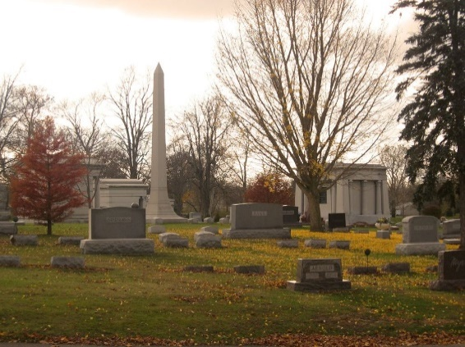
Photo by Tombstoner & Family
Janice Kay Manges, 82, gently passed away to be with her Savior on Sunday morning, November 16, 2025, at Heritage Pointe of Warren.
Kay was born in Garrett on May 12, 1943, to Thomas A. and Georgia (Kelham) Hively, who preceded her in death. She married Hans P. Manges at Merriam Christian Chapel in Merriam, Indiana, on June 15, 1968. He preceded her in death on October 19, 2024.
A 1961 graduate of Wolf Lake High School, Kay later graduated from Manchester College with a bachelor’s degree in education and University of Saint Francis with a master’s degree in education, and a post-graduate degree in Biology. She was a teacher at Crown Point, Goshen, and Norwell high schools. Over the years she enjoyed coaching girls’ basketball, track, volleyball, and cheerleading for a variety of ages.
Kay was involved for several years with the Wells County 4-H Association and the Wells County Homemaker’s Club. She competed at the Indiana State Fair multiple times in sewing and was a 4-H sewing and fashion judge for several counties. Her love of learning continued in Fashion Design at Harper College in Schaumburg, Illinois where she and Hans spent many years commuting from Bluffton for his work. Kay also volunteered with the Wells County Mental Health Association, and she was a member of the Warren Church of Christ.
Kay loved spending time with her grandchildren, children, family, and friends. She also enjoyed substitute teaching, being a Sunday School teacher, foster parenting, taking on new projects, new skills, and had a love of learning for as long as she could.
Survivors include a son, Brian (Katia) Manges of Chesterfield, Virginia; a daughter, Kelly (Troy) Leyse of Monroe; three grandchildren, Makayla (Jason) Cook, Curt Leyse, and Georgia (Jordan) Patterson; a great-grandchild, Axton Cook; and a sister, Mary Schlotterback of Albion.
In addition to her husband and parents, Kay was preceded in death by a sister, LaWanta Sue Weeks; two brothers, Thomas J. Hively and William “Bill” Hively; and a brother-in-law, Terry Schlotterback.
Visitation will be on Saturday, November 22, 2025, from 10:30 AM until 1:00 PM, at Goodwin – Harnish Funeral Home in Bluffton. A funeral service will be held at 1:00 PM on Saturday, immediately following the visitation, with retired pastor and chaplain Gerald Moreland officiating. Burial will follow at Elm Grove Cemetery in Bluffton.
Memorial contributions can be made to Heritage Pointe of Warren in honor of over six years of good care and encouragement from the staff, not only to Kay, but also her family.

Goodwin Funeral Home, Wells County, Indiana
November 16, 2025

