Hans P. Manges
January 1, 1944 - October 19, 2024

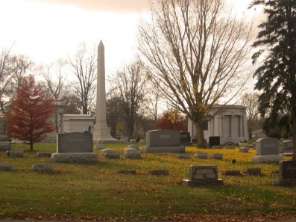
Photo by Tombstoner & Family

Hans P. Manges, 80, passed away Saturday evening, Oct. 19, 2024, at Heritage Pointe of Warren, following an extended illness. Hans was born in Frankfort, IN. on Jan. 1, 1944, to Cline and Rachel (Peterson) Manges, both parents preceded him in death. He married Janice Kay (Hively) at the Merriam Christian Chapel in Merriam on June 15, 1968, she survives in Warren.
He was a member of the Garrett High School class of 1962. Hans went on to serve in the United States Army during the Vietnam War from 1965 until 1967. He then worked for United Airlines for 38 years until he retired. He attended the Warren Church of Christ.
Hans was involved with the Wells County 4-H activities and enjoyed helping with the 4-H pancake booth at Street Fair. He enjoyed tinkering with his Allis Chalmers tractor and spending time out in the barn and his shop. He loved spending time with his family, especially spending time with his grandkids. Hans was a kindhearted man, who would drop anything he was doing to help others in need.
In addition to his wife, Hans is survived by a son Brian (Katia) Manges of Chesterfield, VA; a daughter, Kelly (Troy) Leyse of Bluffton; three grandchildren, Makayla (Jason) Cook, Curt Leyse, and Georgia Leyse; a great-grandchild Axton Cook; two sisters, Gweneth Kandal of Butler, and Joan Aiken of Lafayette; two brothers, Harry (Barb) Manges of Fort Wayne, and Mike (Carol) Manges of Huntington; a sister-in-law, Virginia Manges of North Manchester.
In addition to his parents Hans is preceded in death by a brother, Clyde Manges; two sister Bertha Royer and Nell Grobis; and two brothers-in-law, Donald Royer and Kenneth Grobis.
Visitation will be Friday, Oct. 25, 2024, from 11:30 AM until 2:00 PM, at the Goodwin – Cale & Harnish Memorial Chapel in Bluffton. A funeral service will be held at 2:00 PM on Friday, immediately following the visitation. Chaplain Ginny Soultz will officiate. Burial will follow at Elm Grove Cemetery in Bluffton. Military rites will be conducted by the United States Army Honor Guard and American Legion Post #111 of Bluffton.
Memorial Contributions can be made to Heritage Pointe of Warren.

Goodwin Funeral Home, Wells County, Indiana

