Nola Kathy (Johnson) Kemplen
November 24, 1954 – December 8, 2025

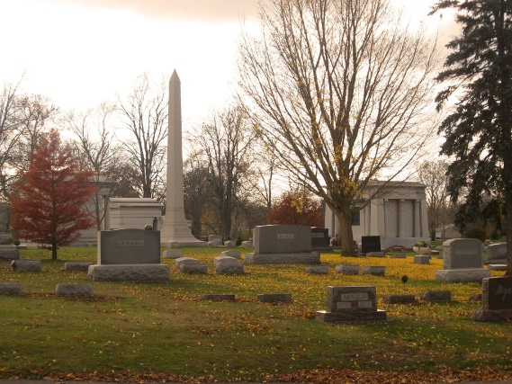
Photo by Tombstoner & Family
Nola “Kathy” Kemplen, age 71, of Bluffton, IN, ascended to her Savior on Monday, December 8, 2025, at her residence. Born November 24, 1954 in Hazard, KY, to Ora and Lucy (Isom) Johnson. Kathy married Wendell Kemplen June 9, 2001, and he remains in Bluffton, IN.
Kathy loved her beloved husband Wendell, her Soulmate. She deeply loved her children and grandchildren, always keeping them close to her heart and above all, always praying that each one would come to know God. Her faith shined brightly, a guiding light. She never doubted or questioned Gods plan.
Kathy loved attending church and would often lift her angelic voice in song, a sound we will all deeply miss.
Her husband, children and grandchildren will feel her absence profoundly, their hearts bearing a void that can never be filled. Though their pain is overwhelming, we take comfort in knowing she is rejoicing in Heaven. “SHE IS HOME”
An avid, involved member of Old Country Church, Hartford City, and a frequent parishioner of First Freewill Baptist Church, Huntington, Kathy also worked various jobs in sales, and as a nursing home caregiver in multiple facilities.
Along with her husband Wendell, Kathy leaves behind four children: Michael (Amy) Plumley, Bluffton, IN, Angela (Lyle) Bumbalough, Bluffton, IN, Alan (Lisa) Plumley, Bluffton, IN, and Rodney (Angela) Plumley, Portland, IN. Nine grandchildren and five great-grandchildren will be missing Grandma Kathy, as well. One sibling survives, Danny Johnson, Hazard, KY. Six siblings precede her in death: Boyd Johnson, Arthur Johnson, Herman Johnson, Geraldine Fields, Carolyn Book, and Patsy Guffy.
Visitation will be Thursday, December 11, from 5 to 7 p.m. at 1805 Salamonie Avenue, Huntington, IN, at the First Freewill Baptist Church. Calling hours will be held on Friday, December 12, 2025, from 10 to 11 a.m., followed with an 11:00 a.m. Funeral Service at the First Freewill Baptist Church. Burial will be at Elm Grove Cemetery, Bluffton, IN.
In lieu of flowers, preferred memorials are to be given to either First Freewill Baptist Church, Huntington, IN, or Old Country Church, Hartford City, IN in care of McElhaney Funeral Home, 715 N. Jefferson St., Huntington, IN 46750.

McElhaney Funeral Home, Wells County, Indiana
December 9, 2025

