Charles Homer Hare
June 16, 1908 – September 1, 1922

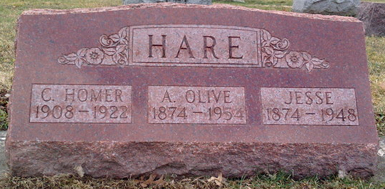
Photo by Thomas Liby

Wells County Lad Killed in Runaway

Bluffton Sept. 2 - Homer Hare, 14 years old, son of Mr. and Mrs. Jesse Hare, living four miles south of town, died shortly after 5 o'clock last night, while being brought to the local hospital. His death was caused by a fractured skull, a fractured shoulder, and possible internal injuries, as the result of a runaway. Young Hare was driving a team of horses when they became frightened and ran away. He was thrown from the wagon and one of the wheels passed over his head, fracturing his skull, while another wheel ran over his right shoulder.
Decatur Daily Democrat, Adams County, Indiana
Saturday, September 2, 1922
**
Indiana, U.S., Death Certificates, 1899-2017

Name: Charles Homer Hare
Gender: Male
Race: White
Age: 14
Marital status: Single
Birth Date: 16 Jun 1908
Birth Place: Shelby Co Illinois
Death Date: 1 Sep 1922
Death Place: Bluffton, Wells, Indiana, USA
Death Registration Date: 1922
Father: Jesse Hare
Mother: Anna Olive Miller
Informant: Jesse Hare; Bluffton, Indiana
Burial: September 4, 1922; Elm Grove Cemetery

