Georgia Anice (Quigley) Crites
February 29, 1904 – December 17, 1993

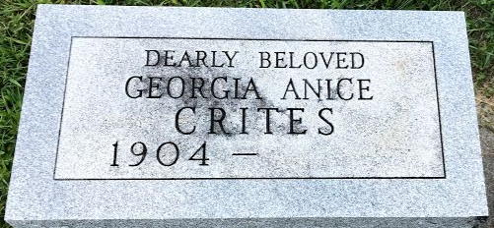
Photo by SMMR

Georgia A. Crites, 89

Former Bluffton resident, Georgia A. Crites, 89, of Lima, Ohio, died at 12:50 p.m. Friday at Lost Creek Care Center.
Born Feb. 29, 1904 in Indiana, she was a daughter of Paul and Effie Mae Stouenberry Quigley. Her marriage was to George U. Crites, who died in 1982.
She was a member of the Baptist Church at Bluffton and had served as secretary for her husband's industrial machinery distributorship.
Friends may call from 6 to 8 p.m. Sunday at Siferd Westwood Chapel at Lima.
Graveside services will be under the direction of Rev. Scott Hoppe at 10:30 a.m. Monday at Elm Grove Cemetery.

News Banner; Wells County, Indiana
Saturday, December 18, 1993
**
Ohio, U.S., Death Records, 1908-1932, 1938-2018
Name:
[Georgia A Quigley]
[Georgia A Crites]
Gender: Female
Race: White, Not Hispanic (White)
Age: 89
Birth Date: 29 Feb 1904
Birth Place: Indiana, USA
Death Date: 17 Dec 1993
Death Hospital: Other/Nursing Home
Death Place: Allen, USA
Inquest Hospital: Long-Term Care Facilities
Registrar's Certificate Number: 090338
Father: Quigley
Mother: Stouenberry
Inquest Questions: Time of Death: 12:50 PM
Industry: Own Home/At Home
Occupation: Housewife/Homemaker
**
Indiana, U.S., Marriages, 1810-2001
Name: Georgia Anne Stoutenberry
Gender: Female
Race: White
Age: 25
Event Type: Marriage Registration (Marriage)
Birth Date: 29 Feb 1904
Birth Place: Adams
Marriage Date: 10 Jun 1929
Marriage Place: Indiana, United States
Residence Place: Bluffton, Indiana
Father: Paul Grigley Stoutenberry
Mother: Effie May Hawk
Spouse: George Ullman Crites
Page: 111

