Noah E. Call
November 19, 1880 – June 9, 1956

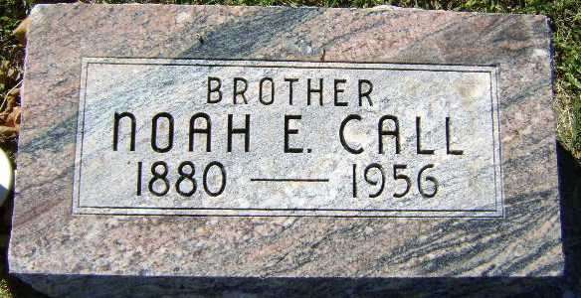
Photo by Bruce Sonner

Noah E. Call Dies Suddenly Saturday
Funeral Services Tuesday Afternoon
Noah E. Call, 76, a resident of Adams County for 15 years, died unexpectedly at 12:15 o’clock Saturday afternoon at the home of his sister, Mrs. Joe Sovine, Craigville Rural Route 1, with whom he had resided for more than 20 years.
He was born in Huntington County Nov. 19, 1879, a son of John and Nancy Dewitt-Call, and was never married. He had been retired a number of years because of failing eyesight.
Mr. Call attended the Christian Union Church at Craigville.
Surviving in addition to the sister is a brother, Joe Call of Craigville Rural Route 1. Two brothers and two sisters preceded him in death.
Funeral services will be conducted at 2 p.m. Tuesday at the Jahn-Goodwin-Reed Funeral Home at Bluffton, the Rev. F. H. Pflugh officiating. Burial will be In Elm Grove Cemetery. Friends may call at the funeral home until time of the services.
Decatur Daily Democrat, Adams County, Indiana
Monday, June 11, 1956

