Lowell M. Burnau
April 15, 1914 – March 25, 1975

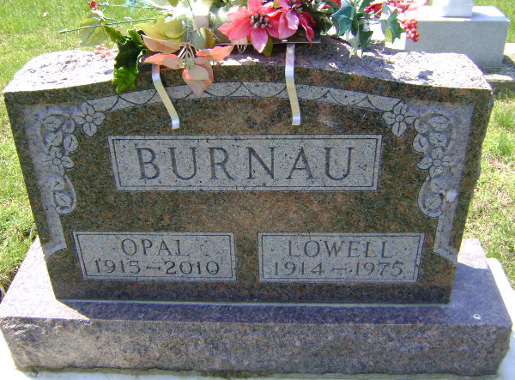
Photo by Bruce Sonner

Lowell M. Burnau
in the Indiana, U.S., Death Certificates, 1899-2011
Name: Lowell M. Burnau
Gender: Male
Race: White
Age: 60
Marital status: Married
Birth Date: 15 Apr 1914
Birth Place: Indiana
Death Date: 25 Mar 1975
Death Place: Bluffton, Wells, Indiana, USA
Father: William Burnau
Mother: Ida Zion
Spouse: Opal Decker
Informant: Patient hospital chart; Bluffton, Indiana
Burial: March 28, 1975; Elm Grove Cemetery; Bluffton, Indiana

