Joseph L. Bumgarner
February 8, 1907 – November 26, 1959

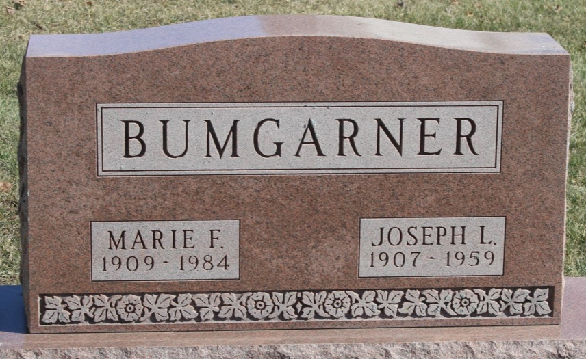
Photo by Tombstoner & Family

Joseph Bungarner
in the Indiana, U.S., Death Certificates, 1899-2011
Name: Joseph Bumgarner
Gender: Male
Race: White
Age: 52
Marital status: Married
Birth Date: 8 Feb 1907
Birth Place: Indiana
Death Date: November 26, 1959
Death Place: Union Twp., Wells, Indiana, USA
Father: Ira Bumgarner
Mother: Louise Myers
Informant: Mrs. Marie Bumgarner; wife; Markle, Indiana
Burial: November 29, 1959; Elm Grove Cemetery; Bluffton, Indiana

