Louise (Winer) Buckner
June 27, 1877 – August 21, 1925

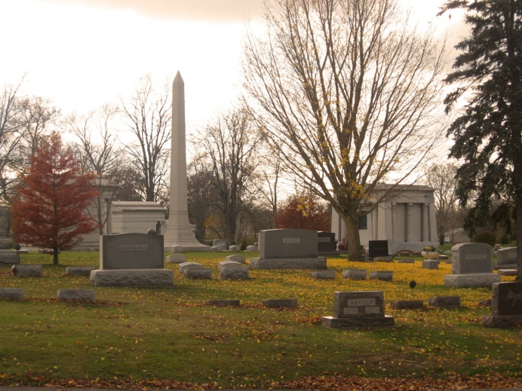
Photo by Tombstoner & Family

Louise Buckner
in the Indiana, U.S., Death Certificates, 1899-2011
Name: Louise Buckner
[Louise Winer]
Gender: Female
Race: White
Age: 48
Marital status: Married
Birth Date: 27 Jun 1877
Birth Place: Indiana
Death Date: 21 Aug 1925
Death Place: Indianapolis, Marion, Indiana, USA
Father: Horace Winer
Mother: Winer
Spouse: Horace Buckner
Informant: Horace Buckner
Burial: August 24, 1925; Bluffton, Indiana

