Harmon Fisher Brubaker
December 18, 1895 – March 31, 1961

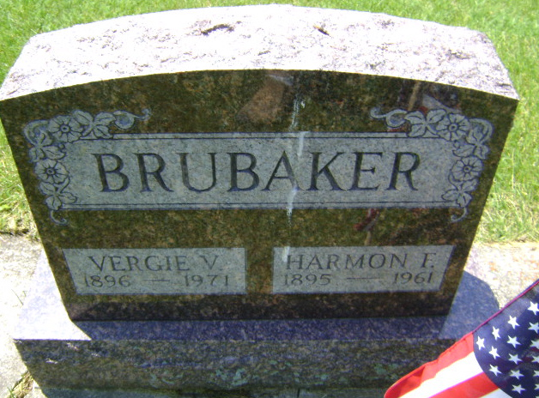
Photo by Bruce Sonner

Harmon F Brubaker
in the Indiana, U.S., Death Certificates, 1899-2011
Name: Harmon F Brubaker
Gender: Male
Race: White
Age: 65
Marital status: Married
Birth Date: 18 Dec 1895
Birth Place: Indiana
Death Date: 31 Mar 1961
Death Place: Wayne, Allen, Indiana, USA
Father: Henry Brubaker
Mother: Lena Fisher
Informant: VA hospital records; Fort Wayne, Indiana
Burial: April 3, 1961; Elm Grove Cemetery; Bluffton, Indiana

