Vernon Harold Brown
May 12, 1925 – June 5, 1997

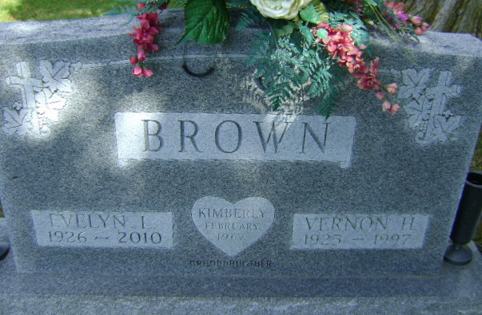
Photo by Bruce Sonner

Vernon Harold Brown
in the Indiana, U.S., Death Certificates, 1899-2011
Name: Vernon Harold Brown
Gender: Male
Race: White
Age: 72
Marital status: Married
Birth Date: 12 May 1925
Birth Place: Tipton, IN
Death Date: 5 Jun 1997
Death Place: Bluffton, Wells, Indiana, USA
Father: Samuel Brown
Mother: Estella Schocke
Spouse: Evelyn L. Knox
Informant: Ted A. Brown; son; Bluffton, Indiana
Burial: June 7, 1997; Elm Grove Cemetery; Bluffton, Indiana

