Ted A. Brown
July 3, 1946 – February 5, 2014

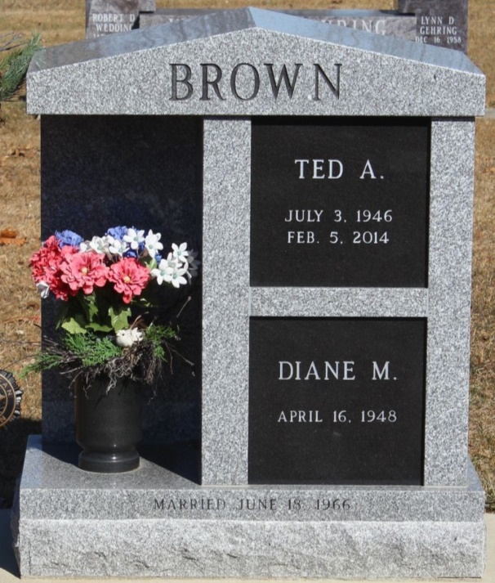
Photo by Tombstoner & Family

Ted A. Brown, 67, of Bluffton, passed away Wednesday, Feb. 5, 2014, at his residence. Ted was born July 3, 1946, in Bluffton, to Vernon Brown and Evelyn Knox Brown. He married Diane M. Miller June 18, 1966, in Bluffton. His wife survives.
Ted graduated from Bluffton High School in 1964. He served in the United States Air Force for four years and in the Air National Guard for 26 years. He worked for General Electric for 16 years and was a member of First Reformed Church.
Survivors include two children, Chris (Stacey) Brown of Huntertown and Michelle (Tony) Mills of Ossian, and three grandchildren. He was an only child. He was preceded in death by a daughter, Kimberley Brown.
Memorial services will be held at 2 p.m. Sunday, Feb. 9, at the Goodwin-Cale & Harnish Memorial Chapel with Dr. Bryson E. Bell officiating. Family and friends can gather from 2 p.m. to 8 p.m. Saturday at the funeral home. Burial will be at the Elm Grove Cemetery in Bluffton. Included in Sunday's services will be rites conducted by the U.S. Air Force and Bluffton American Legion Post 111 in honor of his 30 years of military service.
Memorials may be made to the First Reformed Church, Family LifeCare or the Steve Kelly Foundation

Goodwin Funeral Homes, Wells County, Indiana
February 6, 2014

