Samuel J. Brown
February 8, 1890 – September 5, 1961

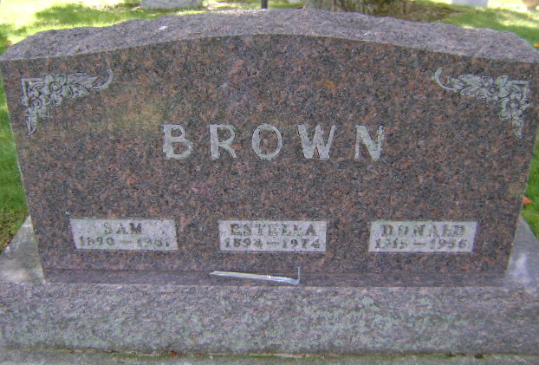
Photo by Bruce Sonner

Samuel F Brown
in the Indiana, U.S., Death Certificates, 1899-2011
Name: Samuel J Brown
Gender: Male
Race: White
Age: 70
Marital status: Married
Birth Date: 8 Feb 1891
Birth Place: Ill
Death Date: 5 Sep 1961
Death Place: Poneto, Wells, Indiana, USA
Father: Elijah L Brown
Mother: Mellissa Conode
Informant: Mrs. S. J. Brown; wife; Poneto, Indiana
Burial: September 8, 1961; Elm Grove Cemetery; Bluffton, Indiana

