Joseph E. Brown
September 19, 1916 – June 4, 1938

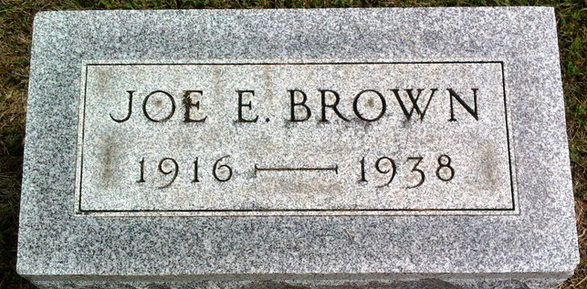
Photo by Thomas Liby

Joseph E Brown
in the Indiana, U.S., Death Certificates, 1899-2011
Name: Joseph E Brown
Gender: Male
Race: White
Age: 21
Marital status: Single
Birth Date: 19 Sep 1916
Birth Place: Indiana
Death Date: 4 Jun 1938
Death Place: Indianapolis, Marion, Indiana, USA
Father: Everett Brown
Mother: Maria Anderson
Informant: Everett Brown; Indianapolis, Indiana
Burial: June 6, 1938; Bluffton, Indiana

