Joan M. (Hackman) Brown
January 16, 1914 – November 30, 1987

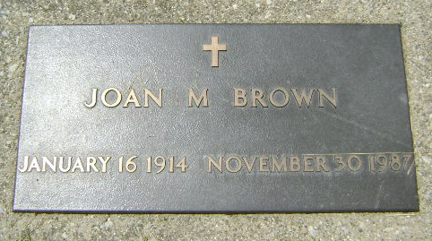
Photo by Bruce Sonner

Joan M Brown
in the Indiana, U.S., Death Certificates, 1899-2011
Name: Joan M Brown
[Joan M Hackman]
Gender: Female
Race: White
Age: 73
Marital status: Widowed
Birth Date: 16 Jan 1914
Birth Place: Danville
Death Date: 30 Nov 1987
Death Place: Danville, Hendricks, Indiana, USA
Father: Roy Hackman
Mother: Bessie Steward
Informant: Nancy Todd; daughter; Speedway, Indiana
Burial: December 2, 1987; Elm Grove Cemetery; Bluffton, Indiana

