Eugene Louis Brown
September 29, 1919 – April 1, 2000

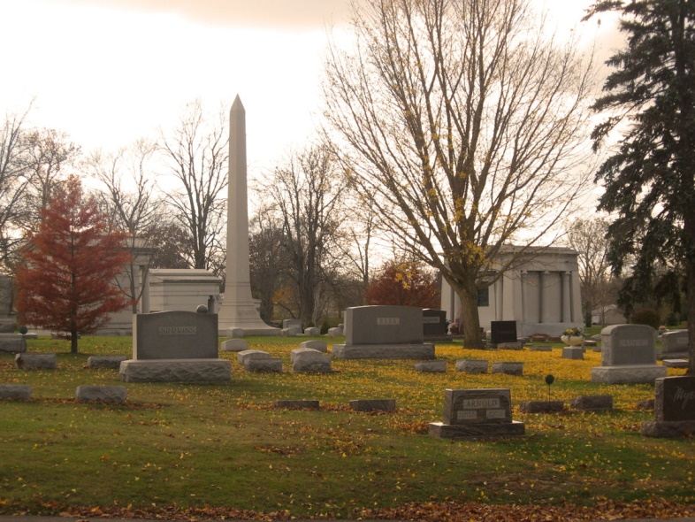
Photo by Tombstoner & Family

Eugene L. Brown
in the Indiana, U.S., Death Certificates, 1899-2011
Name: Eugene L. Brown
Gender: Male
Race: White
Age: 80
Marital status: Widowed
Birth Date: 29 Sep 1919
Birth Place: Bluffton, Indiana
Death Date: 1 Apr 2000
Death Place: Indianapolis, Marion, Indiana, USA
Father: Everett I. Brown
Mother: Grace Marie Anderson
Informant: Patrick Kenneth Brown; son; Zionsville, Indiana
Burial: April 5, 2000; Elm Grove Cemetery; Bluffton, Indiana

