William A. Brineman
August 29, 1903 – January 1, 1946

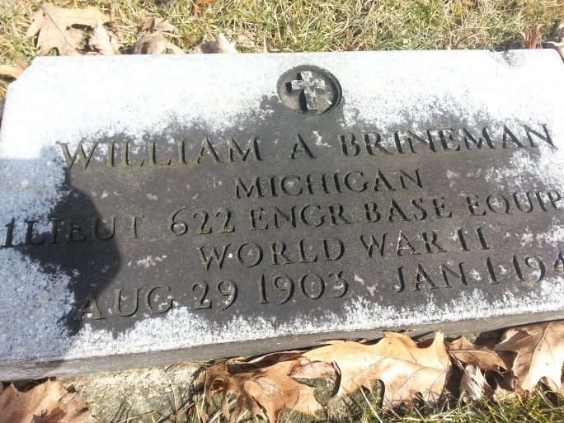
Photo by Dixie Sheckels-Cruz

William A Brineman
in the U.S., Headstone Applications for Military Veterans, 1925-1970
Name: William A Brineman
Birth Date: 29 Aug 1903
Service Number: 02055297
Service Branch: Army
Unit: 622 Engr Base Equig Co, A/S: C E
Enlistment Date: 7 May 1942
Death Date: 1 Jan 1946
Cemetery: Elm Grove Cemetery
Cemetery Location: Bluffton, Indiana, USA

