Cora Belle (Cudner) Brickner
August 20, 1869 – August 17, 1953

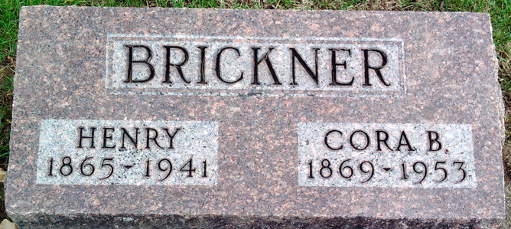
Photo by Thomas Liby

Coradelle Brickner
in the Indiana, U.S., Death Certificates, 1899-2011
Name: Cora Belle Brickner
[Cora Belle Cudner]
Gender: Female
Race: White
Age: 84
Marital status: Widowed
Birth Date: 20 Aug 1869
Birth Place: Mendon, Michigan
Death Date: 17 Aug 1953
Death Place: Fort Wayne, Allen, Indiana, USA
Father: John Cudner
Mother: Julia
Informant: Mrs. Hazel Rowe; Fort Wayne, Indiana
Burial: August 19, 1953; Elm Grove Cemetery; Bluffton, Indiana

