Frank A. Brickley
October 15, 1893 – October 14, 1979

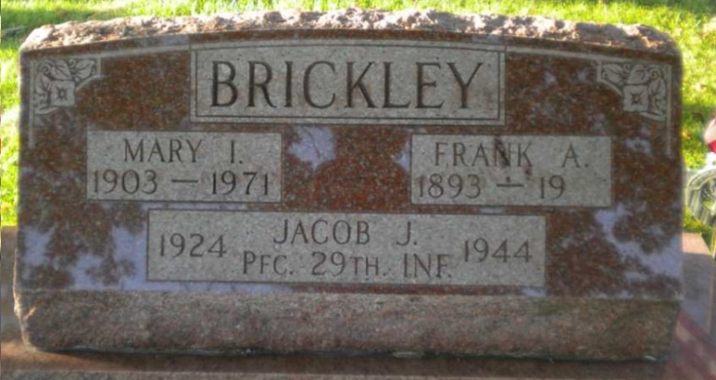
Photo by PLGS

Frank A Brickley
in the Indiana, U.S., Death Certificates, 1899-2011
Name: Frank A Brickley
Gender: Male
Race: White
Age: 85
Marital status: Widowed
Birth Date: 15 Oct 1893
Birth Place: Indiana
Death Date: 14 Oct 1979
Death Place: Bluffton, Wells, Indiana, USA
Father: Andrew Brickley
Mother: Emma Nash
Informant: Jim Barrick; Uniondale, Indiana
Burial: October 17, 1979; Elm Grove Cemetery; Bluffton, Indiana

