David Dwight Bradley
April 28, 1964 – September 25, 2020

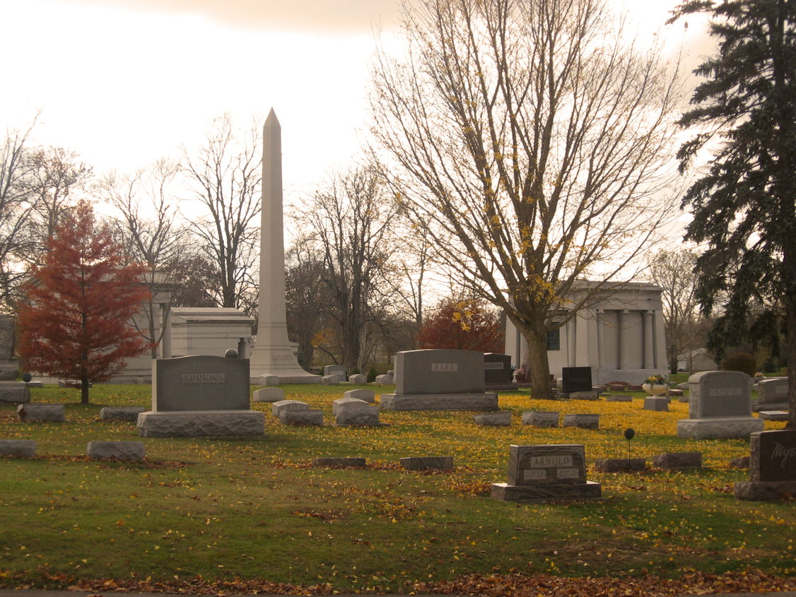
Photo by Tombstoner & Family

David Dwight Bradley, 56 of Bluffton passed away on Friday, September 25, 2020. David was born on April 28, 1964 in Bluffton and attended Southern Wells High Schools. He graduated from Norwell High School with the class of 1981.
He moved to Florida where he worked for 27 years for Epcot Center. David moved back to Indiana in 2013 and worked in factories in Portland, Berne and recently Elkhart Products in Geneva. He enjoyed playing golf, fishing and riding dirt bikes.
Survivors include his parents, Tom & Jane (Ludwig) Bradley of Berne, a daughter Kaylan (Greg) Farrar of Florida, a brother, Chad (Nikia) Bradley, sisters, Heather (Marc) Ulrich & Lisa (Stephen) Roose along with several nieces and nephews.
A graveside service will be held at 2 P.M. on Friday (Oct. 2, 2020) at the Elm Grove Cemetery in Bluffton with Pastor Jody Mounsey officiating.

Thoma/Rich Funeral Home, Wells County, Indiana
September 29, 2020

