Robert L. Boyle
December 27, 1936 – October 18, 1988

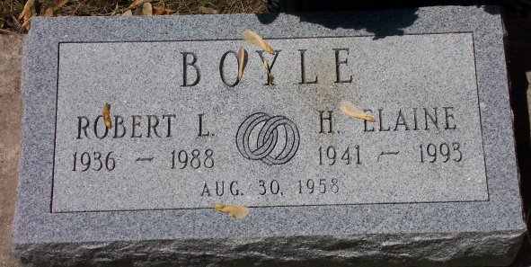
Photo by Bob & Nancy Cannon

Robert L Boyle
in the Indiana, U.S., Death Certificates, 1899-2011
Name: Robert L Boyle
Gender: Male
Race: White
Age: 51
Marital status: Married
Birth Date: 27 Dec 1936
Birth Place: Gaston , In
Death Date: 18 Oct 1988
Death Place: Bluffton, Wells, Indiana, USA
Father: Joseph P Boyle
Mother: Iris Goble
Spouse: Betty Bailey
Informant: Betty L. Boyle; spouse; Bluffton, Indiana
Burial: October 19, 1988; Elm Grove Cemetery; Bluffton, Indiana

