Celia Beatrice (Eichhorn) Bowman
October 17, 1893 – November 9, 1953

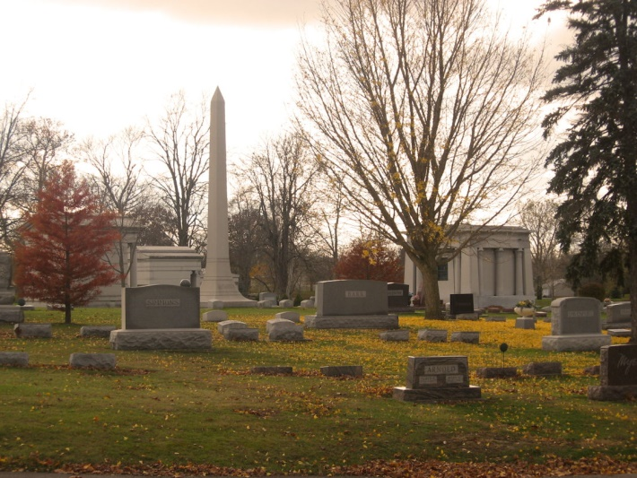
Photo by Tombstoner & Family

MRS. ROB'T BOWMAN DIES AT HOSPITAL

Mrs. Beatrice Bowman, 60, of Lancaster Township died at 2:15 Monday afternoon at the Clinic Hospital. She had been in ill health the past 18 months and death was attributed to carcinoma.
The decedent was born Oct. 17, 1893 in Wells County to David and Mary Griffin Eichhorn. Her marriage to Robert Bowman took place Mar. 4, 1920 in Wells County. She was a member of the Lancaster Chapel Church and was an active member of its various organizations. She was also a member of the Wells County Chorus and the Home Economics Clubs.
Surviving besides the husband are a daughter, Mrs. Robert Jarrett, Fort Wayne; a son, Dale Bowman, at home; three sisters, Mrs. Pearl Lesh and Mrs. Elva Paxson, both of Bluffton and Mrs. Floa (sic) Wible, Fort Wayne and two grandchildren. A son and two brothers are deceased.
The body is at the Jahn Funeral Home where friends may call after 5 o'clock this afternoon. Funeral services will be held at 2 o'clock Thursday afternoon at the Lancaster Chapel Church with Rev. C. L. Davis officiating. Burial will be in the Elm Grove Cemetery.

Bluffton Evening News, Wells County, Indiana
November 10, 1953

*****
Indiana, U.S., Death Certificates, 1899-2011

Name: Celia Beatrice Bowmon
[Celia Beatrice Eichorn]
Gender: Female
Race: White
Age: 60
Marital status: Married
Birth Date: 17 Oct 1893
Birth Place: Indiana
Death Date: 9 Nov 1953
Death Place: Bluffton, Wells, Indiana, USA
Father: David Eichorn
Mother: Mary Griffin
Informant: Oliva Hunt, R.N.; Clinic Hospital
Burial: November 12, 1953; Elm Grove Cemetery; Bluffton, Indiana

