Anna Lucinda (Speheger) Bauer
April 27, 1885 – May 11, 1952

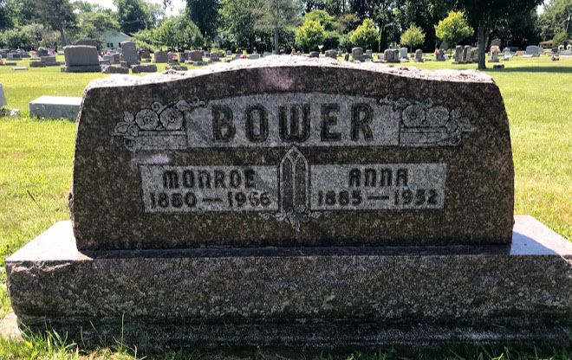
Photo by SMMR

Anna Bower
in the Indiana, Death Certificates, 1899-2011
Name: Anna Bower
[Anna Speheger]
Gender: Female
Race: White
Age: 67
Birth Date: 27 Apr 1885
Birth Place: Indiana
Death Date: 11 May 1952
Death Place: Bluffton, Wells, Indiana, USA
Father: Abraham Speheger
Mother: Rebecca Fritz
Informant: J. Bower; Bluffton, Indiana
Burial: May 13, 1952; Elm Grove Cemetery; Bluffton, Indiana

