Jessie Rae (Manship) Booth
January 15, 1892 – September 10, 1986

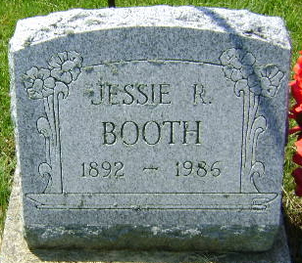
Photo by Bruce Sonner

Jessie R Booth
in the Indiana, U.S., Death Certificates, 1899-2011
Name: Jessie R Booth
[Jessie R Manship]
Gender: Female
Race: White
Age: 94
Marital status: Divorced
Birth Date: 15 Jan 1892
Birth Place: In
Death Date: 10 Sep 1986
Death Place: Bluffton, Wells, Indiana, USA
Father: Robert F Manship
Mother: Mattie Ann Brooks
Informant: Peggy Bate; niece; Bluffton, Indiana
Burial: September 12, 1986; Elm Grove Cemetery; Bluffton, Indiana

