Michael Travis Black
May 27, 1945 – March 1, 2009

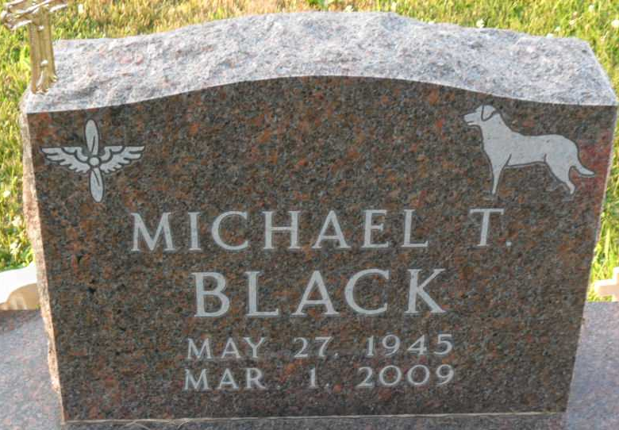
Photo by Thomas Liby

Michael “Mike” Travis Black, 63 of Cromwell, Indiana, passed away Sunday, March, 1, 2009, at his home. Born in Bluffton, Indiana on May 27, 1945, to Martha (Travis) Black Mann and Herbert William Black, he married Daphne (Johnloz) in Uniondale, Indiana on December 17, 1988, she survives.
Mr. Black was a U.S. Air Force Veteran having served during Vietnam (1963-1967). He resided for 30 years of his life in Uniondale, Indiana. Mike was the local delivery “Breadman” for Colonial Bakery for 20+ years. Mike was also the owner of Mike’s Lawn Service in North Webster for 20 years. He worked fifteen years as a supervisor at Colbin Tool in Syracuse retiring in 2008.
Mr. Black was a member of West Etna Community Church, North Webster American Legion Post #253, and a life member of the Syracuse V.F.W. Post.
Other surviving relatives include three daughters, Angela Biberstein (husband: Kary) of Bluffton, Indiana, Tonya Aerts (husband: Frank) of LaPorte, Indiana, Wendy Schlagenhauf (husband: Heath) of Bluffton; two sisters, Carol Hoffacker (husband: Stan) of Uniondale, Adrienne Davies (husband: Doyt) of Fort Wayne, Indiana and five grandchildren.
Calling hours will be 4:00 p.m. to 8:00 p.m. on Wednesday, March 4, 2009 at Thoma/Rich, Chaney & Lemler Funeral Home in Bluffton.
Funeral services will be at 10:00 A.M. Thursday, March, 5, 2009 at the Funeral Home with Pastor Bud Winstead officiating. Burial will be at Elm Grove Cemetery with military honors by the American Legion and the U.S. Air Force Honor Guard.
Preferred memorials are to the Disabled American Veterans, West Etna Community Church, or the donor’s choice.

Thoma/Rich, Chaney & Lemler Funeral Home, Wells County, Indiana
March 2, 2009

