Mina Mae (Beery) Bieber
July 18, 1880 – November 19, 1928

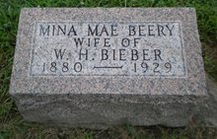
Photo by PLGS

Maria Mae Bieber
in the Indiana, U.S., Death Certificates, 1899-2011
Name: Mina Mae Bieber
[Mina Mae Berry]
Gender: Female
Race: White
Age: 48
Marital status: Married
Birth Date: 18 Jul 1880
Birth Place: Dark Co, Ohio
Death Date: 19 Nov 1928
Death Place: Ind., Allen, Indiana, USA
Father: John H. Berry
Mother: Mary E. Shannon
Spouse: Wm H Bieber
Informant: ?? A. Snyder
Burial: November 22, 1928; Elmwood Grove??

