Howard “Bud” Bennett
1922 - 1944

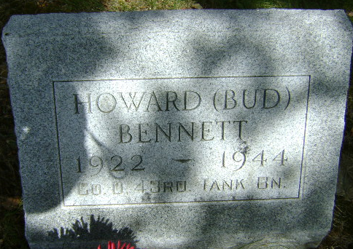
Photo by Bruce Sonner

No further information found at this time

