Helen F. (Freeman) Bennett
September 7, 1864 – May 17, 1954

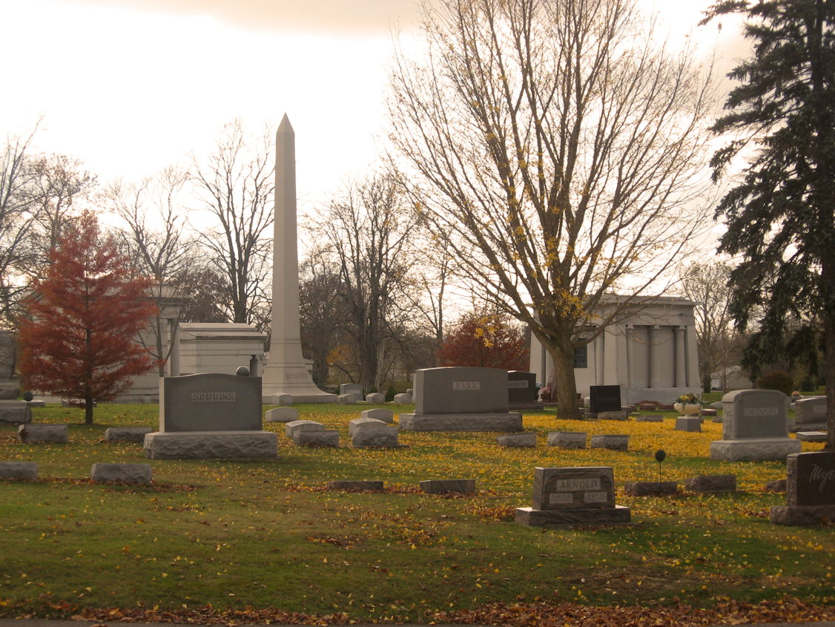
Photo by Tombstoner & Family

Helen F Bennett
in the Indiana, Death Certificates, 1899-2011
Name: Helen F Bennett
[Helen F Freeman]
Gender: Female
Race: White
Age: 89
Marital status: Widowed
Birth Date: 7 Sep 1864
Birth Place: Germany Ind
Death Date: 17 May 1954
Death Place: Indianapolis, Marion, Indiana, USA
Father: Jack Freeman
Mother: Lucinda Bulger
Informant: Robert Gilliland; Indianapolis, Indiana
Burial: May 19, 1954; Fairview Cemetery; Bluffton, Indiana

