Victoria J. “Vickey” (Shady) Bender
November 16, 1876 – May 4, 1957

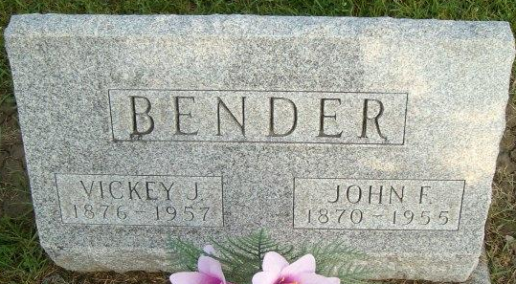
Photo by Smalltown

Vickey Bender
in the Indiana, Death Certificates, 1899-2011
Name: Vickey Bender
[Vickey Shady]
Gender: Female
Race: White
Age: 80
Marital status: Widowed
Birth Date: 1876
Birth Place: Indiana
Death Date: 4 May 1957
Death Place: Bluffton, Wells, Indiana , USA
Father: Martin Shady
Mother: Margaret Leeper
Informant: Jacob Shady; brother; Bluffton, Indiana
Burial: May 6, 1957; Elm Grove Cemetery; Bluffton, Indiana

