John S. Bender
October 12, 1913 – April 5, 2000

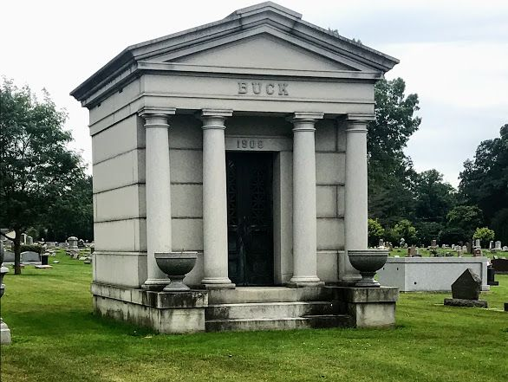
Photo by SMMR

John S. Bender
in the Indiana, Death Certificates, 1899-2011
Name: John S. Bender
Gender: Male
Race: White
Age: 86
Marital status: Married
Birth Date: 12 Oct 1913
Birth Place: Bluffton, In.
Death Date: 5 Apr 2000
Death Place: Angola, Steuben, Indiana, USA
Father: Herbert H. Bender
Mother: Alline Buck
Spouse: Henrietta Carnes
Informant: Henrietta Bender; wife; Coldwater, Michigan
Entombment: April 10, 2000; Elm Grove Cemetery; Bluffton, Indiana

