Charles P. Bender
1857 - 1939

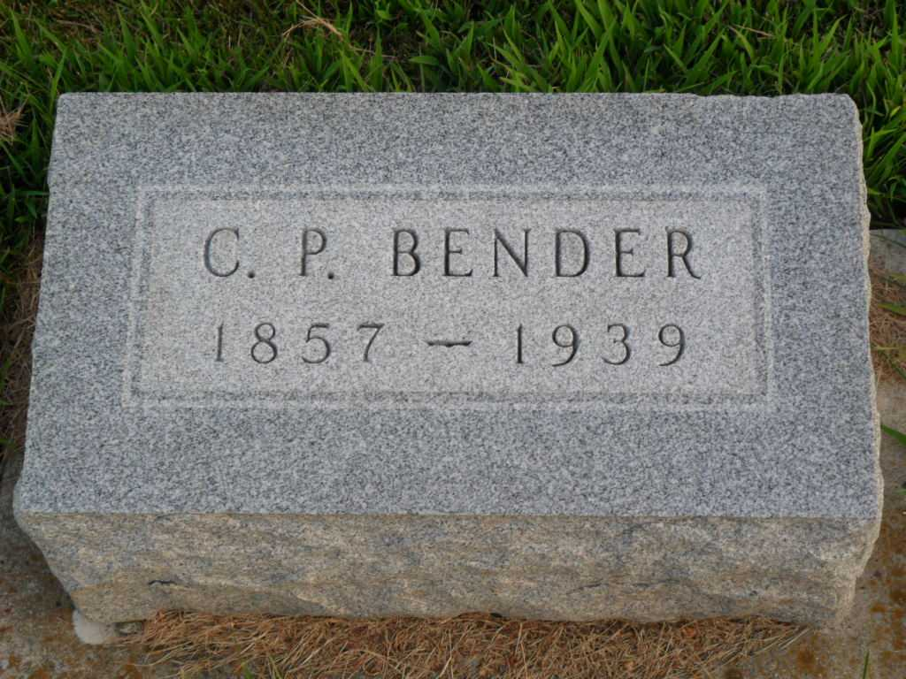
Photo by PLGS

No further information found at this time

