Oliver Dwight Bell
February 3, 1903 – May 15, 1954

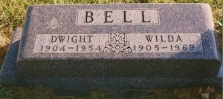
Photo by Bruce Sonner

Dwight Bell
in the Indiana, Death Certificates, 1899-2011
Name: Dwight Bell
Gender: Male
Race: White
Age: 51
Marital status: Married
Birth Date: 3 Feb 1903
Birth Place: Adams Co
Death Date: 15 May 1954
Death Place: Bluffton, Wells, Indiana, USA
Father: H H Bell
Mother: Bessie Houck
Informant: wife
Burial: May 19, 1954; Elm Grove Cemetery; Bluffton, Indiana

