Edward Joseph Bell
August 4, 1923 – October 24, 1950

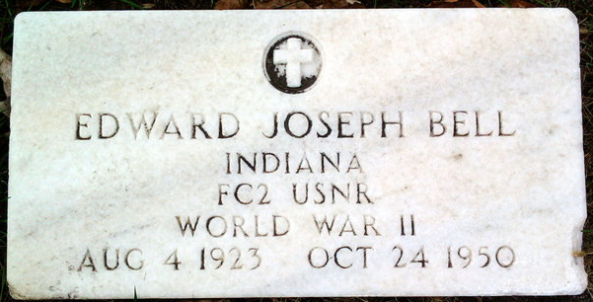
Photo by Thomas Liby

Edward J Bell
in the U.S., Headstone Applications for Military Veterans, 1925-1963
Name: Edward J Bell
Enlistment Date: March 17, 1943
Discharge Date: November 13, 1945
Rank: Ind. FC 2/C USNR
Birth Date: 4 Aug 1923
Death Date: 24 Oct 1950
Cemetery: Elm Grove Cemetery
Cemetery Location: Bluffton, Indiana
Applicant: Alice L. Bell; Flora, Indiana; November 1, 1950

