Charles Ervin Beeler
July 12, 1903 - 1979

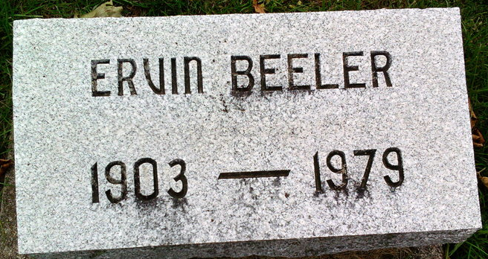
Photo by Thomas Liby

Ervin Beeler
in the U.S., Social Security Death Index, 1935-2014
Name: Ervin Beeler
Social Security Number: xxx
Birth Date: 12 Jul 1903
Issue Year: 1957-1958
Issue State: Indiana
Last Residence: 85351, Sun City, Maricopa, Arizona, USA
Death Date: Feb 1979

