Grace R. (Pearson) Beckler
September 2, 1886 – February 9, 1951

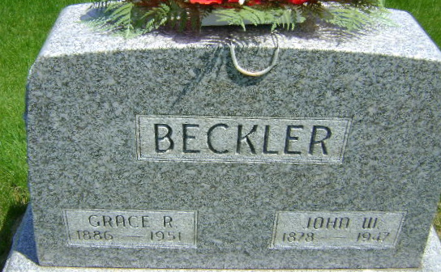
Photo by Bruce Sonner

Grace Beekler
in the Indiana, Death Certificates, 1899-2011
Name: Grace Beekler
[Grace Braxson]
Gender: Female
Race: White
Age: 64
Marital status: Widowed
Birth Date: 2 Sep 1886
Birth Place: Indiana
Death Date: 9 Feb 1951
Death Place: Rural, Wells, Indiana , USA
Father: William N Pearson
Mother: Elizabeth Nelson
Informant: John W. Beckler; Bluffton, Indiana
Burial: Feb. 11, 1951; Elm Grove Cemetery; Bluffton, Indiana

