Clara C. (Monroe) Barton
March 27, 1897 – December 13, 1969

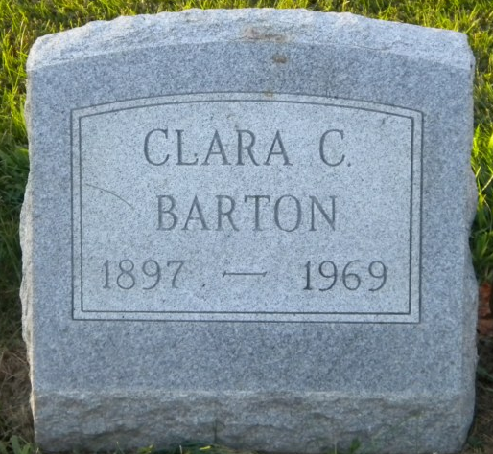
Photo by PLGS

Clara C Barton
in the Indiana, Death Certificates, 1899-2011
Name: Clara C Barton
[Clara C Monroe]
Gender: Female
Race: White
Age: 72
Marital status: Divorced
Birth Date: 27 Mar 1897
Birth Place: Ohio
Death Date: 13 Dec 1969
Death Place: Evansville, Vanderburgh, Indiana, USA
Father: William Monroe
Mother: Mary Wiles
Informant: Mary Fisher; daughter; Stewartsville, Indiana
Burial: December 17, 1969; Elm Grove Cemetery; Bluffton, Indiana

