William Robert Barr
April 22, 1874 – October 1, 1954

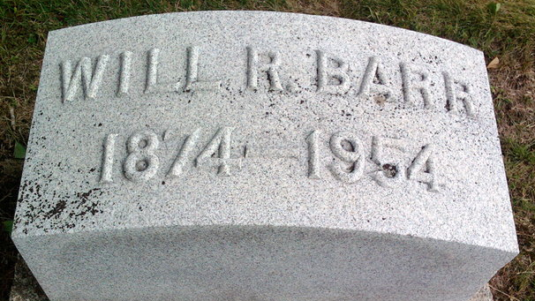
Photo by Thomas Liby

William Robert Barr
in the Indiana, Death Certificates, 1899-2011
Name: William Robert Barr
Gender: Male
Race: White
Age: 80
Marital status: Married
Birth Date: 22 Apr 1874
Birth Place: Indiana
Death Date: 1 Oct 1954
Death Place: Bluffton, Wells, Indiana, USA
Father: Robert Barr
Mother: Celestia Bennett
Informant: Mrs. W. R. Barr; Bluffton, Indiana
Burial: October 4, 1954; Elm Grove Cemetery; Bluffton, Indiana

