Opal May Barr
May 24, 1905 – September 5, 1915

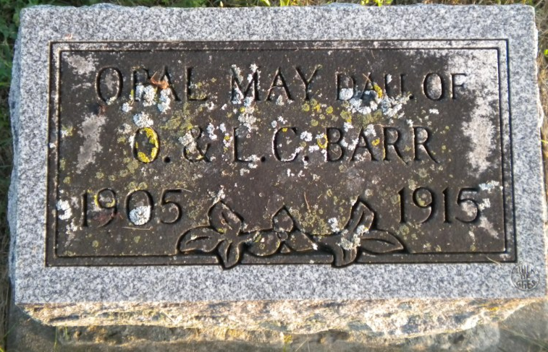
Photo by PLGS

Opal Barr
in the Indiana, Death Certificates, 1899-2011
Name: Opal Barr
Gender: Female
Race: White
Age: 10
Marital status: Single
Birth Date: 24 May 1905
Birth Place: Indiana
Death Date: 5 Sep 1915
Death Place: Union, Huntington, Indiana , USA
Father: Owen Barr
Mother: Lucy Thomas
Informant: Owen Barr; Markle, Indiana
Burial: September 7, 1915; Markle

