Esther Catherine (Meridith) Ball
December 12, 1861 – August 9, 1910

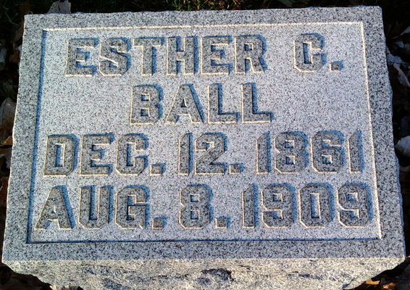
Photo by Thomas Liby

Indiana, Death Certificates, 1899-2011
Name: Esthe Cathrene Ball
[Esthe Cathrene Meridith]
Gender: Female
Race: White
Age: 48
Marital status: Married
Birth Date: 12 Dec 1861
Birth Place: Ind
Death Date: 9 Aug 1910
Death Place: Harris, Wells, Indiana , USA
Father: Jno Meridith
Mother: Lydia Huffman
Spouse: Jessie Ball
Informant: Mrs. Lydia Meridith; Bluffton, Indiana
Burial: August 13, 1910; Grove Cemetery

