Anne Margaret Balentine
February 22, 1953 – September 18, 2010

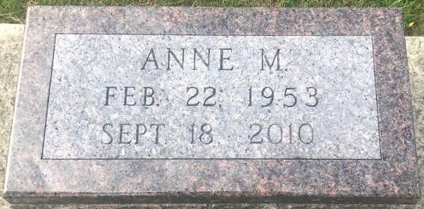
Photo by SMMR

Anne M. Balentine, 57, of Bluffton, the daughter of Margaret Hollohan Balentine and the late Conrad Balentine, passed away at her home Saturday, Sept. 18, 2010, after a long illness. She was born Feb. 22, 1953, in Philadelphia, Pa.
Her mother survives in rural Bluffton. also surviving is a sister, Catherine (James) Mueller of Park Ridge, Ill., nieces and nephews, Emily, Nicholas, Michael, Elizabeth, John "Jack" and Mary Catherine; and Marsha Kunasch of Fort Wayne, her long-time mentor, tutor, and friend.
Despite her deafness and physical disability, Anne was very intelligent. Since Anne was born at a time when there were no schools available to deaf and physically handicapped students who had no mental disabilities, Anne was homeschooled by private tutors. With the help of her tutors, Anne was able to lead a life filled with reading, traveling with her family, her art work, and many other interests.
Calling will be from 2 to 5 p.m. and 6 to 8 p.m. Wednesday, Sept. 22, 2010, at the Goodwin Memorial Chapel, 3220 East State Road 124, Bluffton. There will be additional calling from 9 to 10 a.m. Thursday at the St. Joseph Catholic Church, 1300 North Main St., Bluffton. Mass will be celebrated at the St. Joseph Catholic Church at 10:00 a.m. Thursday. The Rosary Service will be at 4:30 p.m. Wednesday at the funeral home. Father Francis Chukwama and Father Steve Colchin will celebrate the Mass. Burial will be at the Elm Grove Cemetery, Bluffton.
Preferred memorials are to the Anne Margaret Balentine Foundation in care of the funeral home.

Goodwin Funeral Homes, Wells County, Indiana
September 19, 2010

