Roberta Jean (Garton) Arnold
1924 -

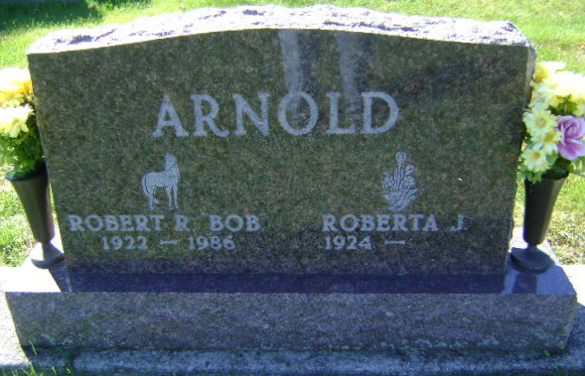
Photo by Bruce Sonner

