Larry Eugene Arnold
October 9, 1940 – November 23, 2004

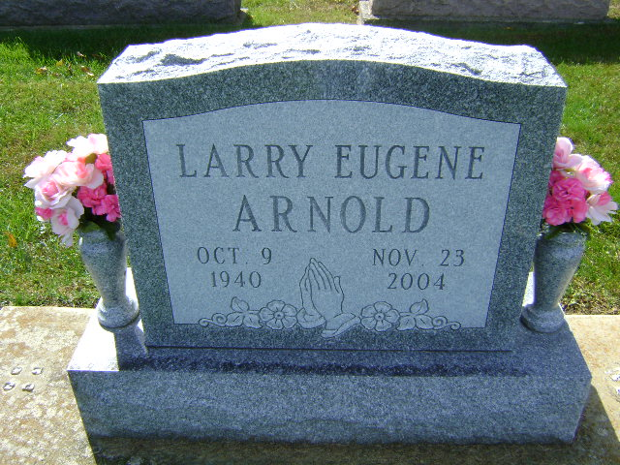
Photo by Bruce Sonner

In failing health the past seven months, Larry Eugene Arnold, 64, of 4684 State Road 201 East, Bluffton, died at 4 p.m. Tuesday, Nov. 23 at his residence. A native of Wells County, Mr. Arnold retired from Franklin Electric in March of this year after 46 years of service. He was a 1958 graduate of Bluffton High School and an avid golfer and sports enthusiast. He attended the First Church of Christ in Bluffton.
Born Oct. 9, 1940 in Bluffton to John and Edith Bowman Arnold, his marriage on Oct. 10, 1987 was to Betty A. Mason, who survives.
Also surviving are two sons, Richard E. Arnold of Ossian and Keith A. Arnold of Bluffton; a daughter, Kellie J. McCart of Indianapolis; two stepsons, David L. Mason of Ossian and Randy L. Mason of Bluffton; two stepdaughters, Joyce L. Crull of Poneto and Judy L. Stewart of Bluffton; five grandchildren, eight step grandchildren; one great grandchild and six step great-grandchildren. Also surviving are a brother, William Arnold of Lafayette, Ga., and three sisters. Mrs. Gerald (Evelyn) Stammen of Fort Recovery, Ohio; Mrs. William (Shirley) Lines of Roanoke and Mrs. Harold (Phyllis) Harness of Plum Tree.
Services will be held at 10:30 a.m. Saturday at the First Church of Christ with Pastor Larry Sprinkle officiating and burial in Elm Grove Cemetery. Calling at Thoma/Rich, Hewitt & Chaney Funeral Home will be Friday from 2 to 8 p.m. and one hour prior to services at the church on Saturday.
Preferred memorials are to Family Hospice of Northeast Indiana.

Bluffton News Banner, Wells County, Indiana
Wednesday, November 24, 2004

