Allen Arnold
January 30, 1868 – July 28, 1920

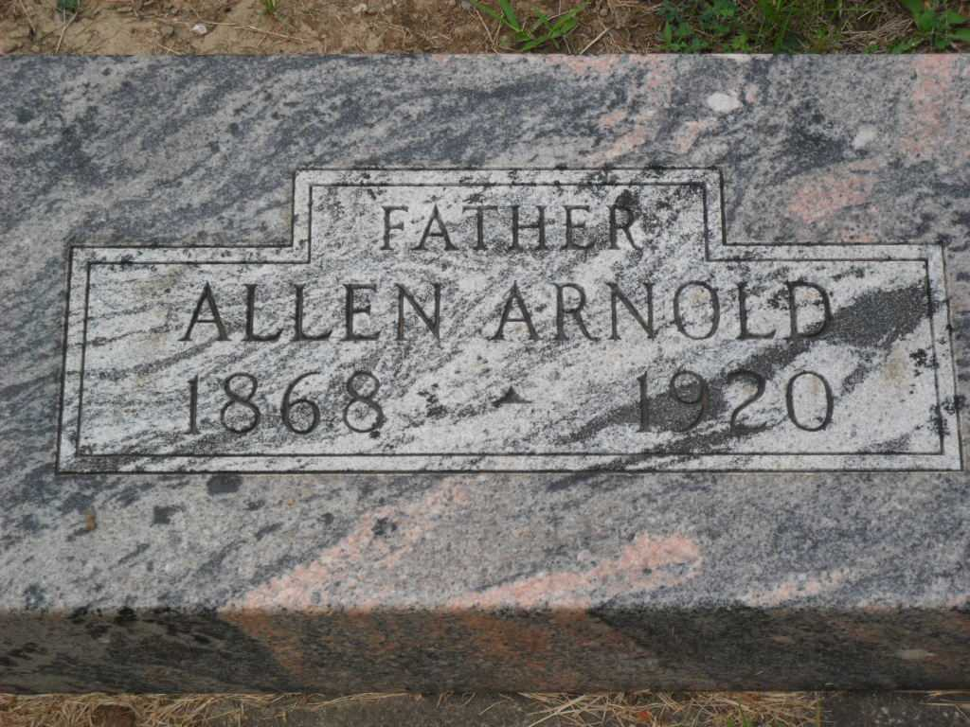
Photo by PLGS

Allen Arnold
in the Indiana, Death Certificates, 1899-2011
Name: Allen Arnold
Gender: Male
Race: White
Age: 52
Marital status: Married
Birth Date: 30 Jan 1868
Birth Place: Wells County Ind.
Death Date: 28 Jul 1920
Death Place: Lancaster, Wells, Indiana, USA
Father: Moses Arnold
Mother: Mary A. Bartlemay
Spouse: Sarah Beeler
Informant: Mrs. Allen Arnold; Bluffton, Indiana
Burial: July 30, 1920; Elm Grove Cemetery

