Valorous A. Armantrout
April 3, 1897 – December 22, 1985

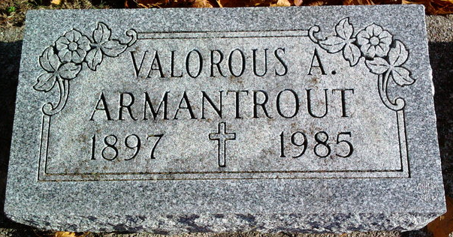
Photo by Thomas Liby

Valorous A Armantrout
in the Indiana, Death Certificates, 1899-2011
Name: Valorous A Armantrout
Gender: Male
Race: White
Age: 88
Marital status: Widowed
Birth Date: 3 Apr 1897
Birth Place: Indiana
Death Date: 22 Dec 1985
Death Place: Bluffton, Wells, Indiana, USA
Father: Elmer Armantrout
Mother: Mary Lois Hite
Spouse: Deceased
Informant: Mrs. Jesse (Mary) Haines; Ossian, Indiana
Cremation: December 24, 1985; Elm Grove Cemetery; Bluffton, Indiana

